 | 12.3.1 Editors - Geometry Nodes Editor - Sidebar - Node tab
Table of content
Node panel 1
Name 1
Label 1
Color Subpanel 1
Presets 1
Node color specials 1
Copy Color 1
Properties panel 1

Node panel

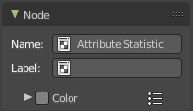
Name
The name of the selected node. Read only.
Despite being read only, this text can be edited. But be careful, it will not change the name in the header of the node. And it does not snap back to the original name of the node when you remove the custom text.

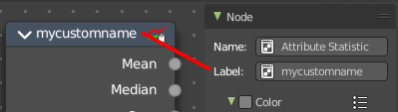
Label
Allows you to define a custom name for the selected node. This text does change the name in the header of the node.

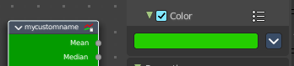
Color Subpanel
Define a custom color for the node. A click at the color field opens a color picker.

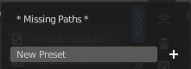
Presets
Add color presets.

Node color specials

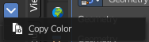
Copy Color
Copies the color. Which doesn't help you since you cannot paste it.

Properties panel

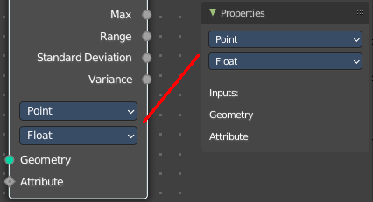
Lists the properties of the node in editable form. And the inputs in text form.

